**ASSIGNMENT FOR PASSING PARAMETERS**

**package** assignment;

**import** org.testng.annotations.Test;

**import** java.util.concurrent.TimeUnit;

**import** org.openqa.selenium.By;

**import** org.openqa.selenium.WebDriver;

**import** org.openqa.selenium.WebElement;

**import** org.openqa.selenium.chrome.ChromeDriver;

**import** org.openqa.selenium.ie.InternetExplorerDriver;

**import** org.testng.Assert;

**import** org.testng.annotations.AfterClass;

**import** org.testng.annotations.BeforeClass;

**import** org.testng.annotations.Optional;

**import** org.testng.annotations.Parameters;

**public** **class** Para {

WebDriver driver;

WebDriver driver1;

@BeforeClass

**public** **void** beforeClass()

{

System.*setProperty*("webdriver.chrome.driver","C:\\ProgramFiles\\Java\\jdk1.8.0_131\\chromeDriver.exe");

driver = **new** ChromeDriver();

System.*setProperty*("webdriver.ie.driver","C:\\Program Files\\Java\\jdk1.8.0_131\\IEDriverServer.exe");

driver1 = **new** InternetExplorerDriver();

driver.get("http://www.google.com");

driver.manage().timeouts().implicitlyWait(10, TimeUnit.***SECONDS***);

driver1.get("http://www.google.com");

driver1.manage().timeouts().implicitlyWait(10, TimeUnit.***SECONDS***);

} @Test

@Parameters({"author","searchKey"})

**public** **void** testParameterWithXML( @Optional("Abc") String author,String searchKey) **throws** InterruptedException{

WebElement searchText = driver.findElement(By.*name*("q"));

WebElement searchText1 = driver1.findElement(By.*name*("q"));

//Searching text in google text box

searchText.sendKeys(searchKey);

searchText1.sendKeys(searchKey);

System.***out***.println("Welcome ->"+author+" Your search key is->"+searchKey);

Thread.*sleep*(3000);

System.***out***.println("Value in Google Search Box = "+searchText1.getAttribute("value") +" ::: Value given by input = "+searchKey);

Assert.*assertTrue*(searchText1.getAttribute("value").equalsIgnoreCase(searchKey));

}

@AfterClass//called after every method

**public** **void** afterClass() {

driver.quit();

driver.quit();

}

}

**XML CODE**:

<?xml version="1.0" encoding="UTF-8"?>

<!DOCTYPE suite SYSTEM "http://testng.org/testng-1.0.dtd" >

<suite name="TestSuite" thread-count="3" >

<test name="test1">

<parameter name="author" value=" John" />

<parameter name="searchKey" value=" San Ramon" />

<classes>

<class name="assignment.Para">

</class>

</classes>

</test>

<test name="test2">

<parameter name="author" value=" Mary" />

<parameter name="searchKey" value=" Pleasanton" />

<classes>

<class name="assignment.Para">

</class>

</classes>

</test>

</suite>

**OUTPUT:**

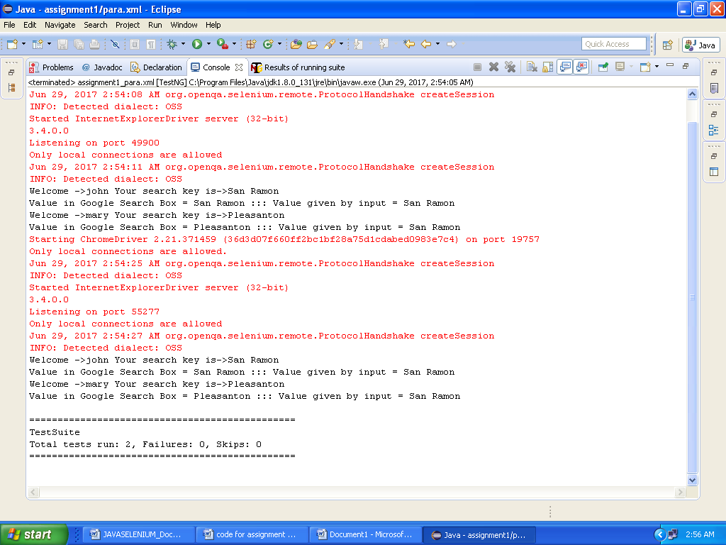

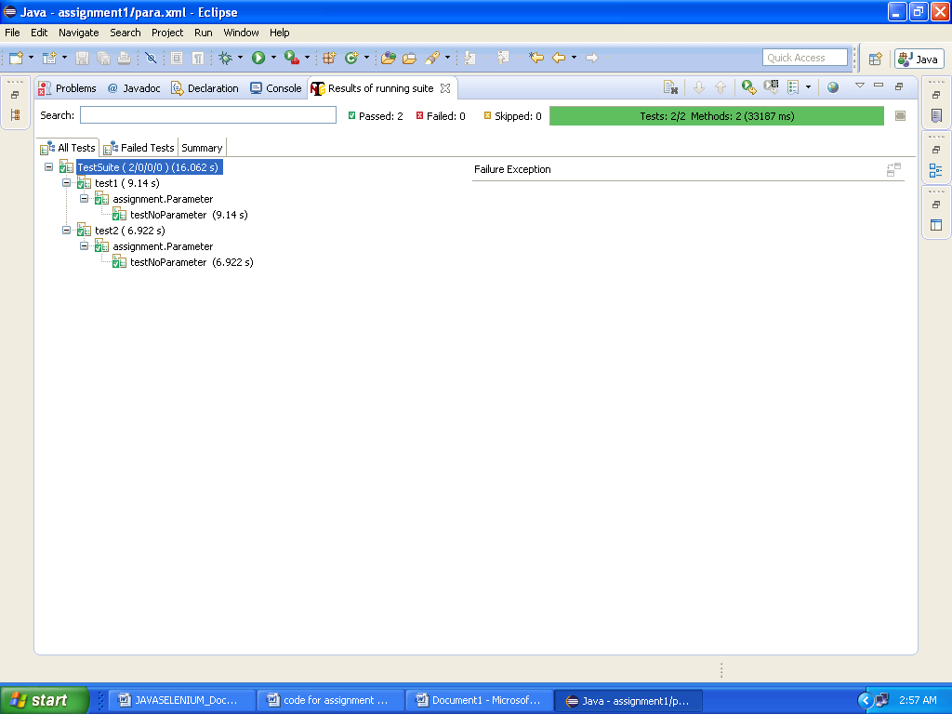

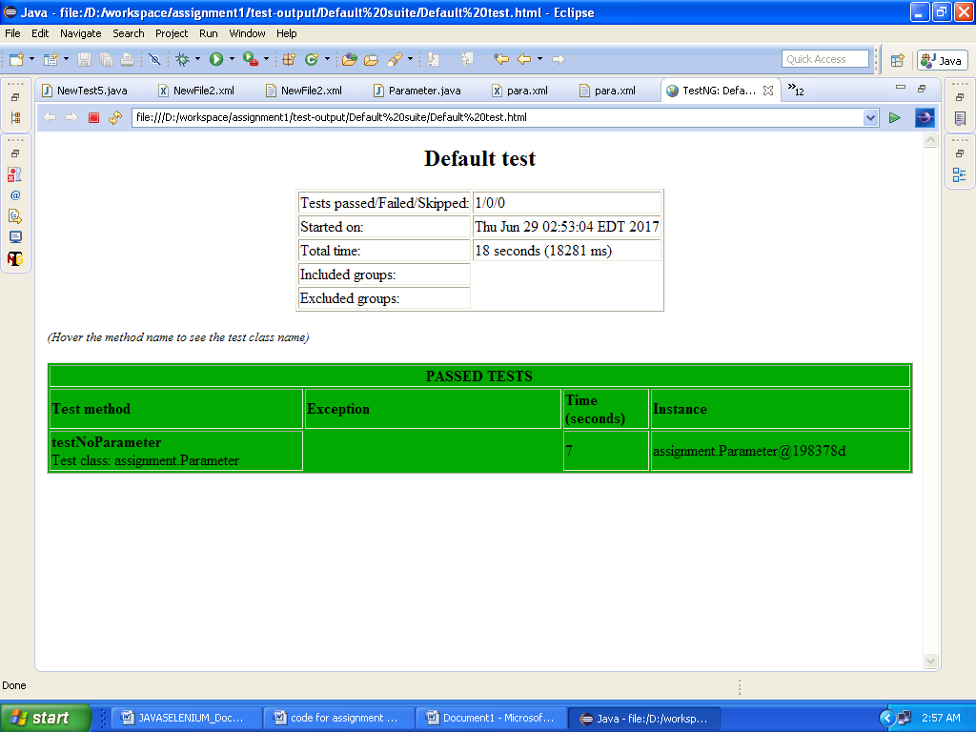

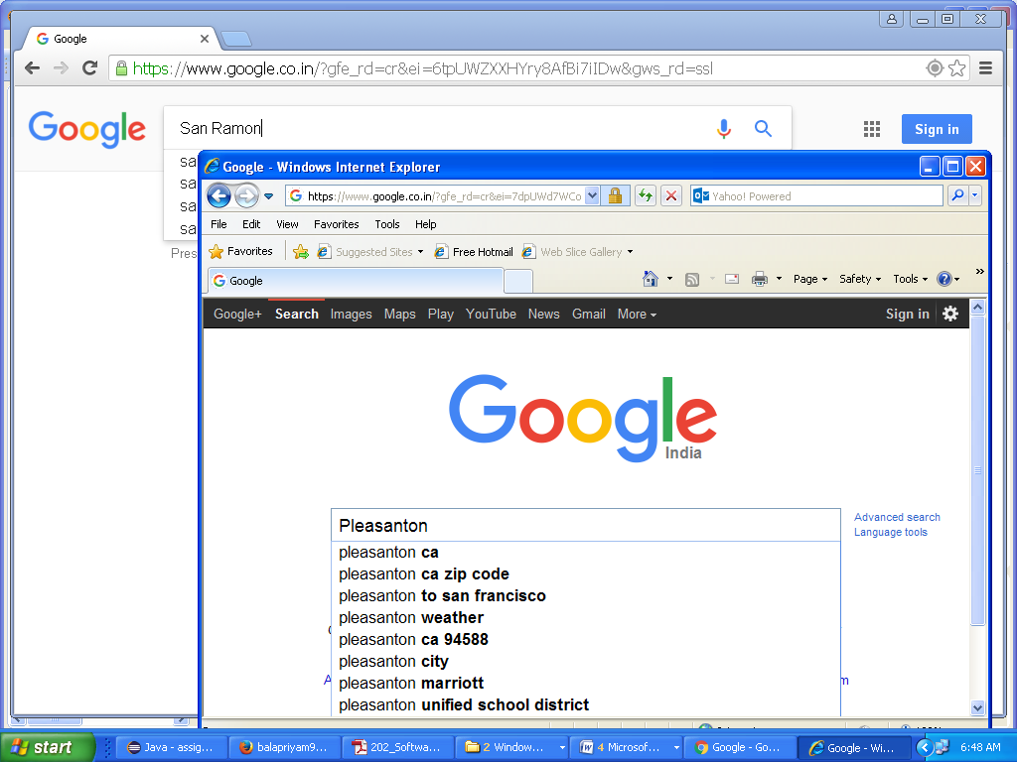

**ASSIGNMENT FOR YAHOOMAIL**

**package** assignment;

**import** java.util.concurrent.TimeUnit;

**import** org.testng.annotations.Test;

**import** org.openqa.selenium.By;

**import** org.openqa.selenium.WebDriver;

**import** org.openqa.selenium.WebElement;

**import** org.openqa.selenium.chrome.ChromeDriver;

**public** **class** Yahoo {

**private** WebDriver driver;

@Test

**public** **void** login1()

{

WebDriver driver; System.*setProperty*("webdriver.chrome.driver","C:\\Program Files\\Java\\jdk1.8.0_131\\chromedriver.exe");

driver = **new** ChromeDriver();

driver.get("http://yahoomail.com") ;

**//enter email id**

WebElement element=driver.findElement (By.*id*("login-username"));element.sendKeys("balapriyam95@yahoo.com");

**//click next button**

driver.findElement(By.*id*("login-signin")).click();

driver.manage().timeouts().implicitlyWait(5, TimeUnit.***SECONDS***);

WebElement element1=driver.findElement (By.*id*("login-passwd"));

element1.sendKeys("**********");

driver.findElement(By.*id*("login-signin")).click();

driver.findElement(By.*id*("yui_3_10_3_1_1375219693637_127")).click(); driver.manage().timeouts().implicitlyWait(5, TimeUnit.***SECONDS***); driver.findElement(By.*id*("yucs-signout")).click();

}

}

**OUTPUT:**

